**Cellular Automaton Model**

问与答

1. 用元胞自动机模拟蚯蚓运动可以给我们带来什么?

蚯蚓作为工程菌的载体可以自由移动，在运动过程中通过进食富集土壤中的铅。这样一来，蚯蚓运动遍布的范围大致上等同于蚯蚓净化土壤的范围。通过设置一系列模型构建规则，元胞自动机可以以一定概率自动模拟物质的扩散，我们希望通过元胞自动机模拟蚯蚓在土壤中的运动并记录蚯蚓的位置。在得到蚯蚓的运动轨迹后，容易得到蚯蚓净化土壤的范围。

1. 什么因素吸引蚯蚓运动？

蚯蚓的运动很容易受到环境的影响。根据湿度、有机质含量、地理特征和该处蚯蚓实时数量等因素对耕地进行吸引力划分。其中，蚯蚓实时数量对吸引力有相反的作用。这样一来，吸引力将成为蚯蚓运动的关键，蚯蚓的轨迹可以预测。

1. 如何将蚯蚓进食和净化土壤铅离子结合？

每只蚯蚓都具有一定的处理铅的能力，这个能力来源于其携带的工程菌（经过改造的枯草芽孢杆菌）。在进行模拟前，我们将蚯蚓处理铅的能力具体化，类似，单只蚯蚓处理铅的效果。蚯蚓每次进食富集铅后，都会应用这种能力处理铅。

**Q&A**

**1. What can Cellular Automaton do?**

As the carrier of engineered bacteria (*Bacillus Subtilis*), earthworm can move freely and enrich the lead in the soil by eating during the movement. In this way, the range of movement is roughly equivalent to the range of soil purification by earthworms. By setting a series of model rules, Cellular Automata can automatically simulate material diffusion with certain probability. We hope to use Cellular Automata to simulate the movement of earthworms in soil and record the location of them. The range of soil purification by earthworms can be easily obtained after the movement track of earthworms is obtained.

**2.** **What makes earthworms move?**

The movement of earthworms is easily affected by the environment. We assess the attraction of different locations according to the factors such as humidity, organic matter content, geographical features and the real-time number of earthworms. Among them, the real-time number of earthworms had the opposite effect on attraction. In this way, attraction will be the key to the earthworm's movement, and earthworm's trajectory could be predicted.

**3. What is the connection between earthworm feeding and soil lead purification?**

The engineered bacteria ~~(~~*~~Bacillus Subtilis~~*~~)~~ that earthworms carry enable them to deal with lead in the soil. Before the simulation, we’d like to crystallize the ability of processing lead, similarly, the efficiency of soil lead purification by a single earthworm. Earthworms would use this ability to address soil lead pollution every time they feed.

**1 摘要**

本项目的目标是通过释放携带重新设计的枯草芽孢杆菌的蚯蚓来处理土壤铅污染问题。为了指导实验，提出最佳蚯蚓释放策略，我们构建了一个**Cellular Automaton**模型以获取不同策略的效果。基于模型机制，它可以拓展为处理世界不同地区的耕地铅污染问题。本文对不同的释放策略进行定性分析，给出了一些一般的结果和相对较好的释放策略。

**1 ABSTRACT**

Our project is to address soil lead pollution by releasing earthworms carrying the redesigned *Bacillus subtilis*. To guide experiments and propose optimal earthworm release strategies, we constructed the Cellular Automaton Model to obtain the effects of different strategies. Based on its mechanism, the model could be used to deal with lead pollution of cultivated land in different regions around the world. In this project, different release strategies are analyzed qualitatively, and some general results and release strategies are given.

**2 模型假设**

1. 由于一次投放处理时间较短，在蚯蚓处理土壤铅污染期间不考虑蚯蚓死亡率。
2. 由于地形不同等因素，对不同地区元胞设置不同吸引力。
3. 间隔分散投放方式显然优于集中投放，本模型中只寻求最佳间隔投放蚯蚓方案。
4. 蚯蚓一天活跃时间为8小时，并认为该时间段内蚯蚓一直处于进食状态。
5. 蚯蚓一天时间进食量较少，我们假设蚯蚓一天时间内可以处理完当天进食富集的所有铅离子。
6. 蚯蚓一天的进食量等于其自身体重。

**2 MODEL ASSUMPTIONS**

1. Earthworm mortality is not considered during soil lead purification by earthworms due to the short treatment time of a single discharge.
2. Due to different terrains and other factors, we set different attractions for different regions.
3. Dispersive feeding is obviously better than centralized feeding, and our model only seek for the best interval earthworm feeding scheme.
4. The active time of earthworms is 8 hours in a day, and it is believed that earthworms are always eating during this time.
5. Since earthworms consume less food in one day, we assume that earthworms can process all the lead enriched by food in one day.
6. An earthworm eats as much as its own weight in a day.

**3 参数说明**

**3 SYMBOL DESCRIPTION**

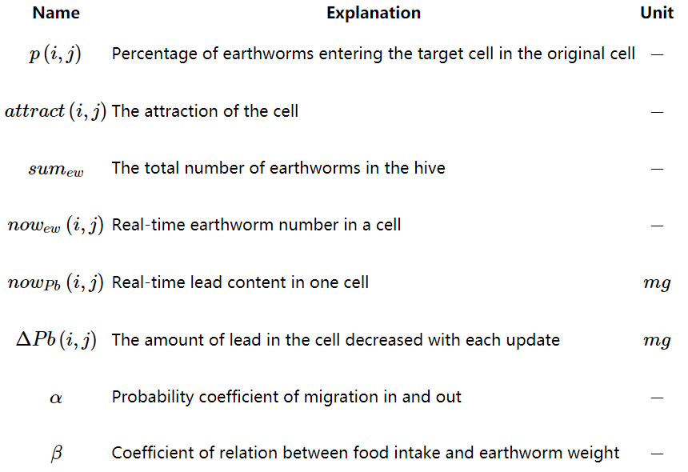

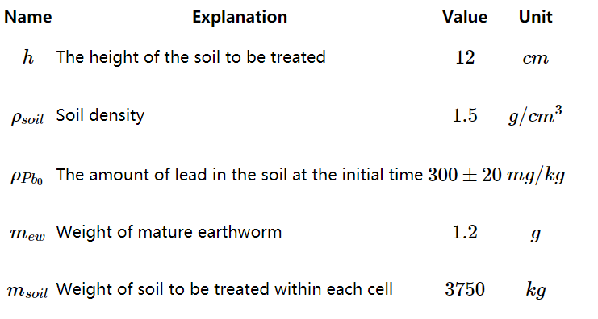

**4 模型建立**

**4.1 元胞自动机简介**

通过设置一系列模型构建规则，细胞自动机[[2]](https://2019.igem.org/Team:NAU-CHINA/CA_Model#i4)可以以一定概率自动模拟物质的扩散。在动态系统中，元胞自动机可以分为“均匀，周期性和混沌结构”三种类型。考虑到蚯蚓活动的聚集和周期性以及地形引起的边界条件的复杂性，具有周期性结构的细胞自动机明显优越。在算法复杂度和准确性方面，元胞自动机的性能也优于偏微分方程。

**4 MODEL**

**4.1 INTRODUCTION TO CELLULAR AUTOMATON**

By setting a series of model construction rules, the Cellular Automaton[[1]](https://2019.igem.org/Team:NAU-CHINA/CA_Model#i4) can automatically simulate the diffusion of substances with a certain probability. In dynamic systems, cellular automata can be divided into three types: uniform, periodic and chaotic structure. With a view to the aggregation and periodicity of insect activity and the complexity of boundary conditions caused by topography, the Cellular Automaton with periodic structure is obviously superior. In terms of algorithm complexity and accuracy, the Cellular Automaton performs better than the partial differential equation.

**4.2 建立环境地图**

考虑到蚯蚓活动的范围和地形特征，我们将蜂窝大小设置为500 m×500 m。此外，考虑到有效范围，我们将元胞数设置为100×100，因此，整个环境地图代表一个覆盖2500平方米的正方形地区。

考虑到蚯蚓活动易受到土壤条件、有机物质等的影响，我们应用矩阵简化了地形图，并根据地形特点和土壤条件对地图进行了吸引力划分。由于很难获得准确的地形图，因此我们使用根据南京农业大学白马教学科研基地的地形特征以及目标耕地的有机质分布情况随机生成地图。然后将地图简化为100×100的（0,80）矩阵其中80表示最高吸引力区域，0表示最低吸引力区域。该矩阵如下图4.2.1所示。

**4.2 BUILDING AN ENVIRONMENTAL MAP**

Considering the range of earthworm activities and topographic features, we set the size of the hive at **500 m×500 m**. In addition, considering the effective range, we set the number of cells to **100×100**. So, the entire environmental map represents a square area covering **2,500 square meters**.

Considering that earthworm activity is easily affected by soil conditions and organic substances, we use matrix to simplify topographic map and classify the map according to topographic characteristics and soil conditions. Since it is difficult to obtain accurate topographic maps, we use random maps generated according to the topographic features of Jiangsu Nanjing Baima National Agricultural Science and Technology Zone, and the distribution of organic matter in the target cultivated land. The map is then reduced to a 100 by 100 **(0,80)** matrix where 80 represents the highest attractive region and 0 represents the lowest attractive region. The matrix is shown in **Figure 4.2.1** .

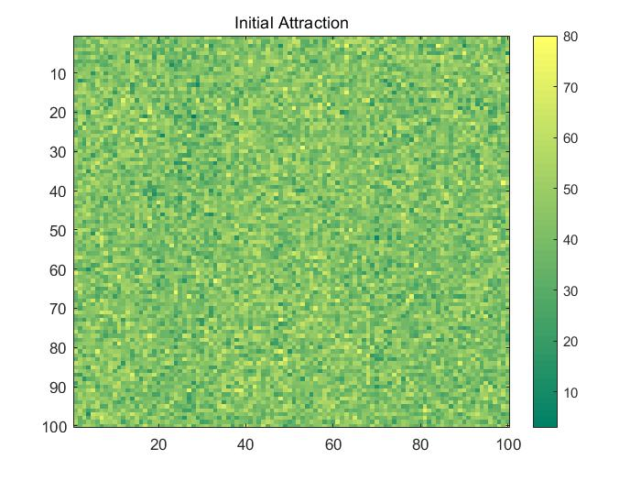

Fig 4.2.1

**4.3 蚯蚓在元胞中**

1. 为了尽可能真实地模拟蚯蚓的分布，我们将待处理土地简化为二维图形。以蚯蚓投放的距离间隔为50米、每堆投放数目为10000只为例，元胞自动机初始状态时的蚯蚓分布如图4.3.1所示。
2. 细胞内所有蚯蚓都有一定的概率迁移到附近的格(细胞)。蚯蚓更容易被“极具吸引力”的细胞所吸引，而远离“低吸引力”的细胞。因此，在元胞自动机演化2个月后，蚯蚓的分布情况如图4.3.2所示。

3. 为了便记录蚯蚓运动状况，我们为蚯蚓设立一些运动规则。

a. 蚯蚓迁入迁出元胞概率计算公式 ;

迁入迁出概率正比于元胞吸引力，并且和目标位置蚯蚓数量反相关。这里，为了得到无量纲量我们采用相对蚯蚓数量，同时引入迁入迁出概率系数 α。

b. 单个元胞每日pb变化量公式 ；

土壤铅含量的变化主要和蚯蚓进食相关，引入进食量与蚯蚓体重关系系数 β。

**4.3 THE EARTHWORMS IN THE CELL**

1. In order to simulate the distribution of earthworms in the real life, we abstracted the area into a two-dimensional figure. We first simulated the situation when the distance between earthworms was 50 meters and the number of earthworms in each pile was 10000. The earthworm distribution in the initial state of cellular automata is shown in **Figure 4.3.1**.

2. All earthworms in the cell have a certain probability to migrate to the nearby cells. Earthworms are more likely to gravitate toward the "highly attractive" cells and stay away from the "less attractive" cells. Therefore, after **2 months** of cellular automata evolution, the distribution of earthworms is shown in**Figure 4.3.2.**

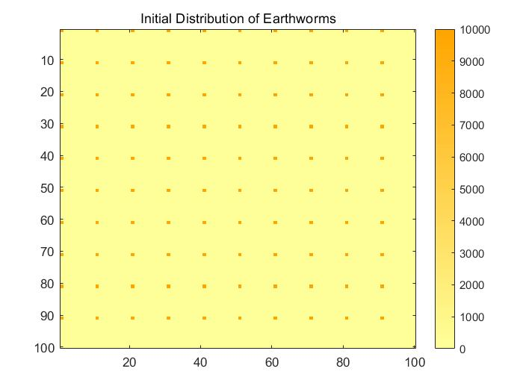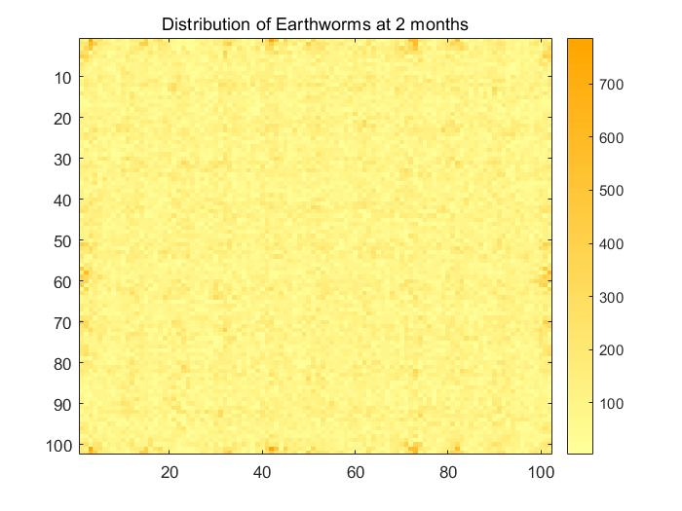

Fig 4.3.1 Fig 4.3.2

3. In order to record the movement status of earthworms, we set up some movement rules for earthworms.

a. Formula of earthworm migration in and out cellular probability

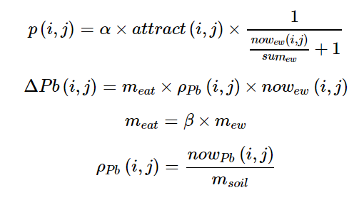

The probability of migration in and out is proportional to cellular attractiveness and inversely correlated with the number of earthworms in the target location. Here, in order to obtain the dimensionless quantity, we use the relative earthworm number and introduce α，the probability coefficient of migration in and out.

b. Formula of real-time lead variation in a single cell





The change of soil lead concentration was mainly related to earthworm feeding, and we introduced β，a coefficient of relation between food intake and earthworm weight.

**5 模拟结果和分析**

基于上述模型设定，在间隔为50米、每堆投放10000只蚯蚓时，经过两个月，目标土地的铅残留情况如图5.1所示。

Fig 5.1

结果表明：经过两个月的处理，蚯蚓初始释放点土壤铅浓度较处理前下降10%左右，蚯蚓已有小面积的扩散，但扩散距离较小。基于此，我们决定对投放方案进行调整，以寻求更加优越的处理效果。

此后，我们对其他蚯蚓投放方案进行了模拟分析，蚯蚓投放间隔距离从1米扩大到100米，每堆投放数量从500扩大到10000只，得到不同处理组合的处理效果，如图5.2。

Fig 5.2

**5 RESULTS & ANALYSIS**

Based on the above model setting, when 10,000 earthworms were put into each pile at an interval of 50 meters, after two months, the lead residue of the target land was shown in **Figure 5.1** and **Figure 5.2**

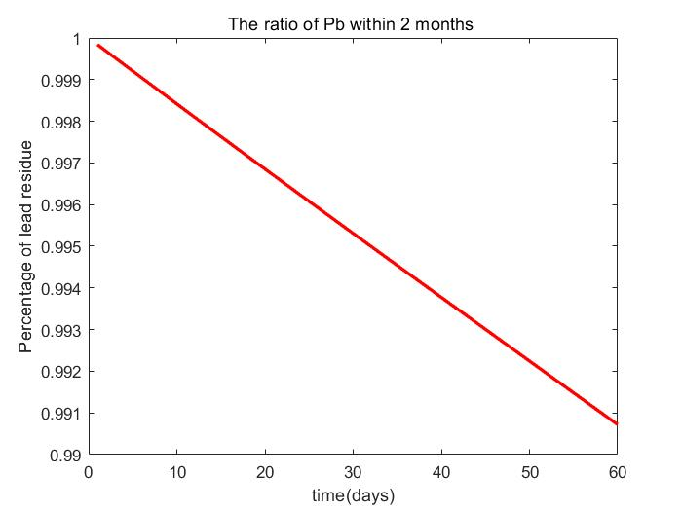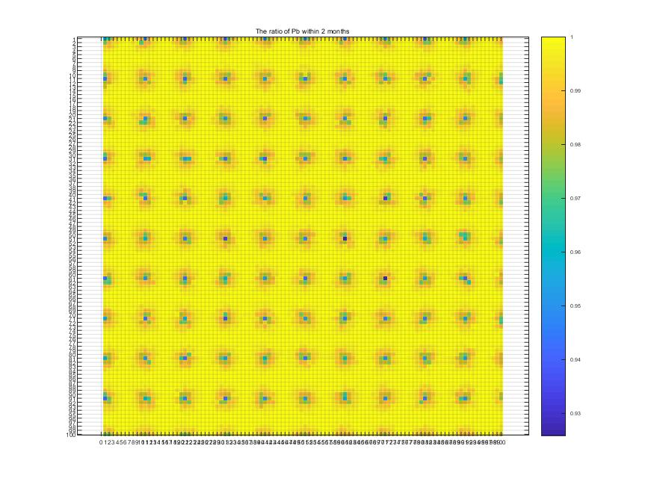

Fig 5.1 Fig 5.2(gif)

The results suggested that after two months of treatment, the lead concentration in the soil at the initial release point of earthworms decreased by about **10%** , and the earthworms had spread in a small area, but with a small distance. Based on this, we decided to adjust the scheme to seek more superior treatment effect.

After that, we carried out simulation analysis on other earthworm feeding schemes. The distance between earthworm feeding was expanded **from 1 meter to 100 meters**, and the number of earthworm each pile was expanded **from 500 to 10,000.** Finally, the treatment effects of different treatment combinations were obtained, as shown in **Figure 5.3**.

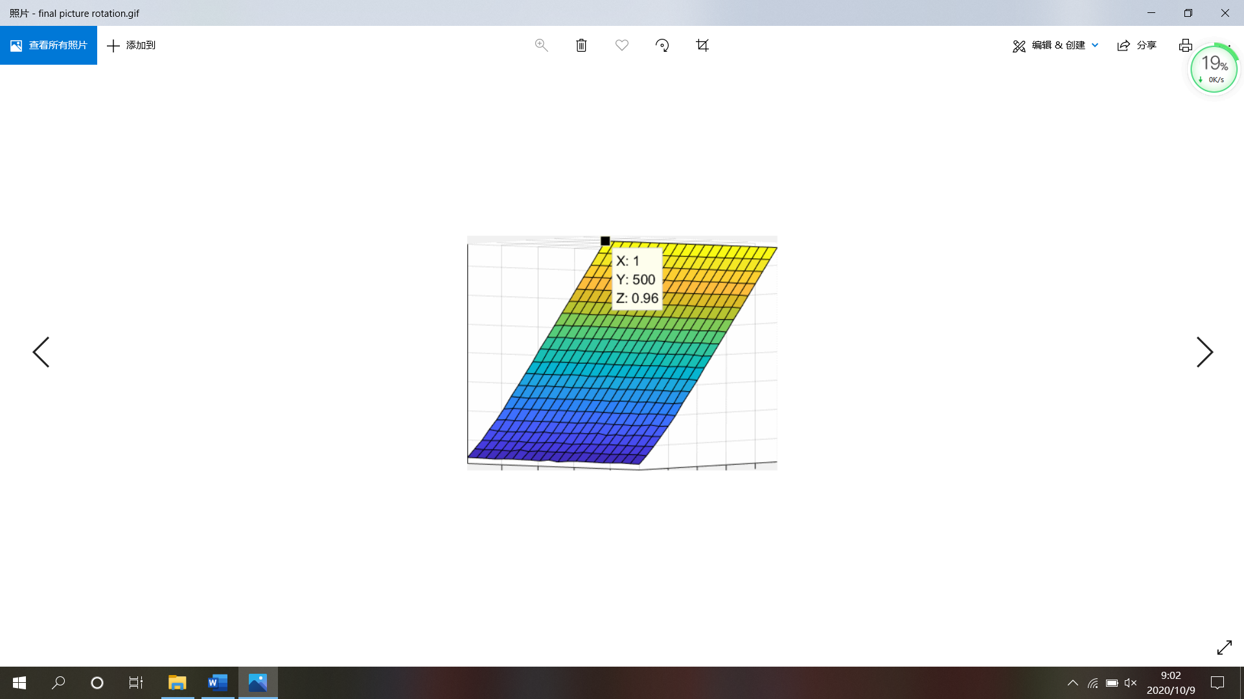

Fig 5.3(gif)

**6 敏感性分析**

敏感性分析，也称敏感度分析，是通过计算一个或者多个不确定性因素的变化所导致的终极指标的变化幅度，分析各个因素的变化对实现预期目标的影响程度，从而为项目决策提供重要的依据。

**迁入和迁出概率系数**

由于蚯蚓迁入和迁出元胞的概率难以确定，模型初期我们通过函数对参数进行了初步计算，并引入迁入和迁出概率系数。

在这里，我们对迁入和迁出概率系数进行敏感性分析。结果显示如下：

**进食量与蚯蚓体重关系系数**

蚯蚓进食量关乎蚯蚓通过进食富集的铅的含量，而进食量显然与蚯蚓体重相关，在模型中我们添加进食量与蚯蚓体重关系系数，即 β，描述了这种关系

现在，我们对进食量与蚯蚓体重关系系数进行敏感性分析。结果显示如下：

敏感性分析的结果表明：

1. 在一定范围内，迁入和迁出概率系数对土壤铅残留程度影响不大。模型允许迁入和迁出概率系数波动的范围大致为：0.0002-0.0013.
2. 进食量与蚯蚓体重关系系数土壤铅残留程度影响不大。允许波动范围为：0.0012-0.0084.

**6 SENSITIVITY ANALYSIS**

Sensitivity analysis could calculate the change range of the ultimate index caused by the change of one or more uncertain factors, and analyze the impact of the change of each factor on the realization of the expected goal. Therefore, it helps to provide an important advice for project decision.

**Probability coefficient of migration in and out**

Since it is difficult to determine the probability of earthworm migration in and out of cell, we calculated the parameters by function at the beginning of the model, and introduced the probability coefficients of migration in and out.

Here, we conduct sensitivity analysis on the probability coefficients of migration in and out. The results are in **Figure 6.1**

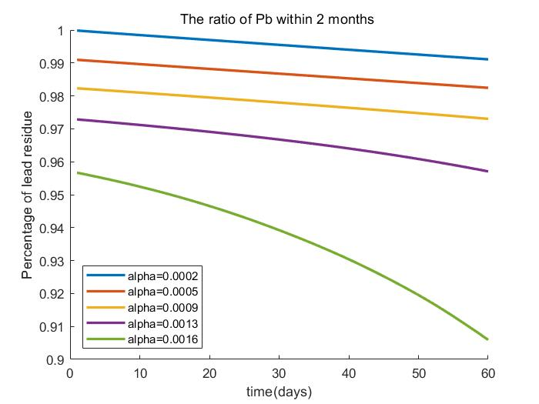

Fig 6.1

**Coefficient of relation between food intake and earthworm weight**

The food intake of earthworms determines the lead enriched by earthworms, and the food intake is obviously related to the weight of earthworms. In the model, we added the coefficient of relation between food intake and the weight of earthworms, namely β, to describe the relationship.

Now, we carried out sensitivity analysis on the coefficient of relation between food intake and earthworm weight. The results are as shown in **Figure 6.2**

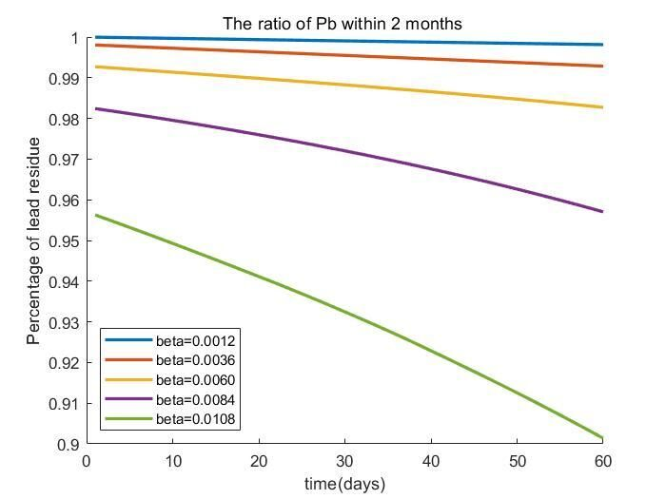

Fig 6.2

The sensitivity analysis results showed that:

1. Within a certain range, probability coefficient of migration in and out has little influence on the degree of lead residue in soil. The probability coefficient fluctuation range of the model is about 0.0002-0.0013.

2. The coefficient of relation between food intake and earthworm weight has little influence on the degree of soil lead residue. The allowable fluctuation range is 0.0012-0.0084.

**Reference**

[1] Song Wei, Chen Baoming, Liu Lin. Research on soil and water conservation,2013,20(02):293-298.

[2] Ceccherini‐Silberstein T, Coornaert M. Cellular Automata and Groups[M]. 2010.

Download the source code (设置为链接)